Capstone Project Weekly Progress Report

|  |  |
| --- | --- |
| Semester | Fall 2021 |
| Course Code | AML 3406 |
| Section | Section 2 |
| Project Title | Restaurant Recommending Chatbot |
| Group Name | Group 3 |
| Student names/Student IDs | Vignesh Kumar Murugananthan C0793760 |
| Reporting Week | Week 4 – 10/02/2021 |
| Faculty Supervisor | Vahid Hadavi |

# **Tasks Outlined in Previous Weekly Progress Report**

* Install all libraries and the platform needed for the project
* Create Azure workspace for Machine Learning
* Install MongoDB in local system to import Json data

# **Progress Made in Reporting Week**

* Created GIT Repository
* Downloaded the latest data from Yelp in Json format
* Loaded them in local repository
* Installed MongoDB in cloud service
* Imported the dataset
* Structured the data

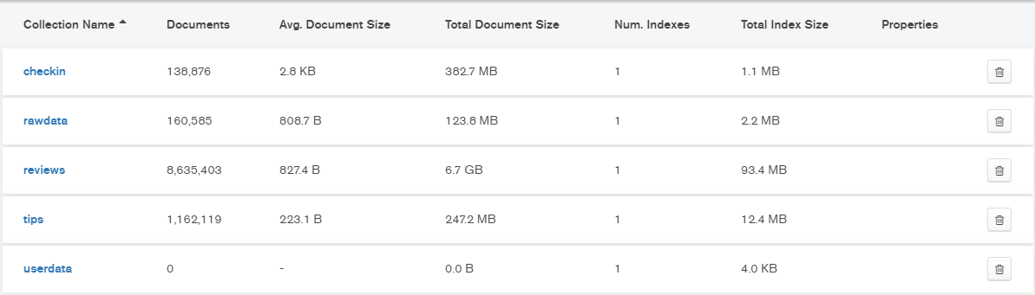

# **Difficulties Encountered in Reporting Week**

* The file size was huge and was new to handle size of that nature.

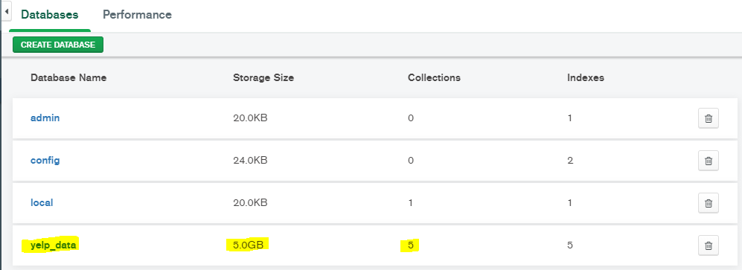

# **Tasks to Be Completed in Next Week**

* Perform initial cleaning of data
* Data Preprocessing
* Apply NLTK processes and structure the data

Overall Project Plan:

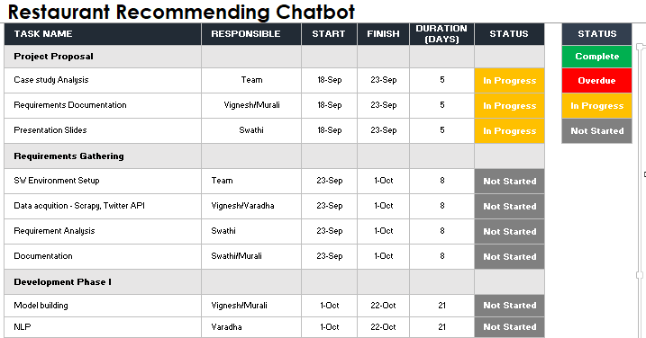

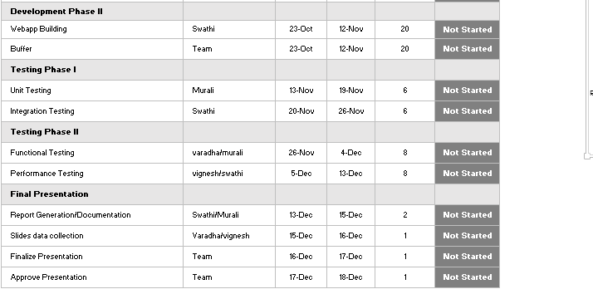

Individual Project plan:

Case study analysis

S/W environment setup

Development phase 1 – NLP

Development Phase 2 – Webapp Building

Testing Phase 2 – UNIT and Integration testing

HIGLIGHTED BELOW ARE MY RESPONSIBILITIES

